Project Design Phase-I

# Solution Architecture

|  |  |
| --- | --- |
| Date | 01 October 2022 |
| Team ID | PNT2022TMID30495 |
| Project Name | Classification of arrhythmia by using deep learning with 2-d |

**Minimum Viable Architecture for MVP**

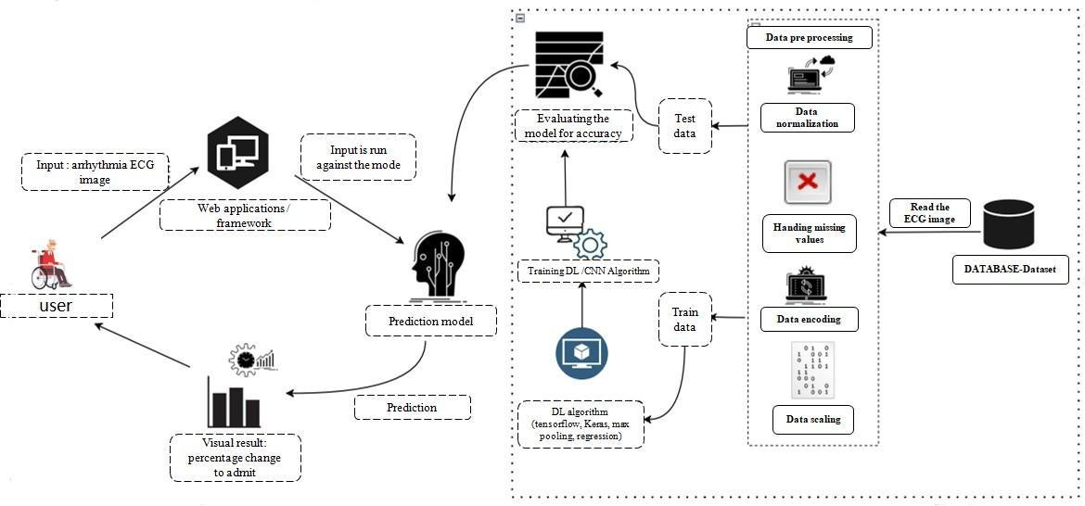

## Technologies needed for Minimum Viable Product deployment

* Working with HTML & CSS Using Frontend
* Working with image processing technique
* Working with Tensorflow capabilities
* Working with Keras capabilities
* Working Trained CNN model
* Build a web application using the Flask framework

## Platform

* Git & GitHub - Project Management
* IBM Cloud - Hosting
* IBM Watson - Training the Deep Learning Mode

